# CS 340 README

About the Project Motivation Getting StartedInstallation Usage

Code Example

Tests

Screenshots

Contact

**About the Project**

This project develops a Python module that enables CRUD (Create, Read, Update, and Delete) functionality for connecting to a MongoDB database. The facilitates the interaction with the "AAC" database and the "animals" collection. The module will later be used to connect the user-interface component of a web application (such as a dashboard) to the database component in Project Two.

## Motivation

CRUD functionality is essential for interacting with databases, and it forms the backbone of any web application that deals with data storage. The motivation behind creating this Python module is to establish a robust and reusable codebase that provides Create, Read, Update, and Delete functionality for the "AAC" database.

## Getting Started

To get a local copy up and running of this project, first you must open the terminal and verify access to the environment by starting up MongoDB and the mongo shell. Import AAC Data Set CSV File into MongoDB. Download the Austin Animal Center Outcomes CSV Spreadsheet [here](https://learn.snhu.edu/content/enforced/1347144-CS-340-X6151-OL-TRAD-UG.23EW6/course_documents/aac_shelter_outcomes.csv?isCourseFile=true&_&d2lSessionVal=ScQoRYLN9OTGv4T9RbCyYwie6&ou=1332057&_&d2lSessionVal=cbRJ7WDzOHHvmwghsre3D5ABX&ou=1347144). Upload the Austin Animal Center (AAC) Outcomes data set into MongoDB by importing a CSV file using the appropriate MongoDB import tool. Use the database name “AAC” and collection name “animals.” Open the Mongo Shell and locate the AAC database. Create a Simple Index, Compound Index to improve the performance. To authenticate a user, an Admin account and an aacuser account needs to be created to access the database.Create a username “aacuser” with read/write privileges to that AAC database. For more information, visit this [link](https://www.mongodb.com/docs/database-tools/mongoimport/).

## Installation

This Python module allows you to interact with MongoDB using pymongo (version 3.12.0) to perform CRUD (Create, Read, Update, Delete) operations on an Animal Shelter database. Before using the module, ensure you have MongoDB installed on your system. Follow the official [MongoDB installation guide](https://www.mongodb.com/docs/manual/installation/#install-mongodb) for your operating system. The module was tested with MongoDB version 6.0.3.

## Usage

### Code Example

The testing script is python_testing.ipynb and currently has all CRUD capabilities. Below is an example:

from animal_shelter import AnimalShelter

#Connect to the database. Replace user, pass, host, and port with your credentials.

CRUD = AnimalShelter ("user","pass",

"host",

port)

Call the **create** method with the CRUD object, passing in the appropriate string or data object:

created = animals.create({ ‘name‘ : ‘Diamond ’ })

To **read,** tests code examples:

query = animals.read({"animal id": "test"})

To **update**, all methods in CRUD take can take in one or many objects:

#first object is the object to be updated and the second object is the updated object

updateAnimal = animals.update({‘animal id’:‘test‘} ,{‘outcome_type’: "Adopted"})

To **delete,** test code example:

deleteAnimal = animals.delete({'animal id': 'test'})

### Tests

The module contains unit tests for the AnimalShelter class to verify its functionality. These tests cover different scenarios, including successful CRUD operations, handling invalid input, and ensuring proper data retrieval.

### Screenshots

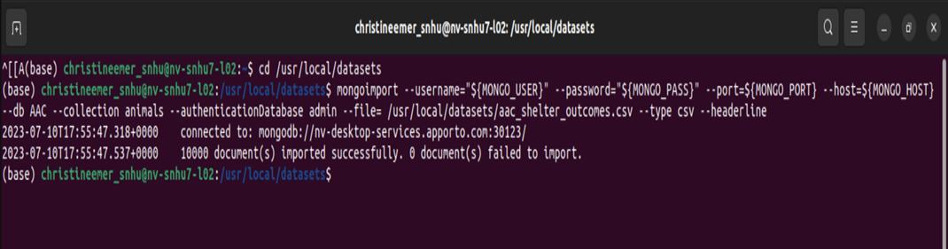

Upload the Austin Animal Center (AAC) Outcomes Dataset

Login Process

## Contact

If you have any questions or need assistance with the Python CRUD module, feel free to reach out:

**Name:** Christine Emerson [Email](mailto:christine.emerson@snhu.edu) [LinkedIn](https://www.linkedin.com/in/christine-emerson-b0631b190)